# *Play Ball!*

Sign-ups for early spring baseball camps will be on **February 26 and 27** at the Green Diamond Center.

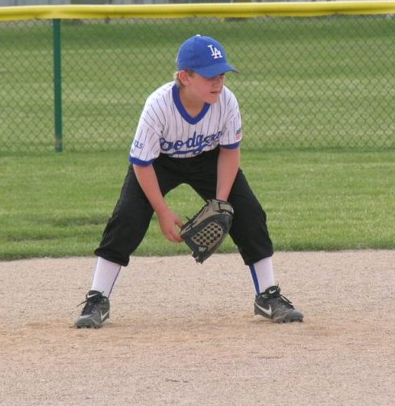

* Indoor facility with batting cages
* Speed and conditioning training
* Pitching, hitting, and fielding practice

## Call Mike at 555-2241 for more information.